**Assignment 4: Create a private bucket in AWS. Upload a file and check by presigned URL that you can access the file or not.**

Creating private bucket and giving access controls

1. Go to **Search** and search S3.
2. Click on **Create Bucket.**

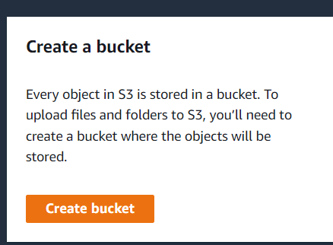

1. Give unique Bucket Name.
2. Check **ACL Disabled(recommended)**.

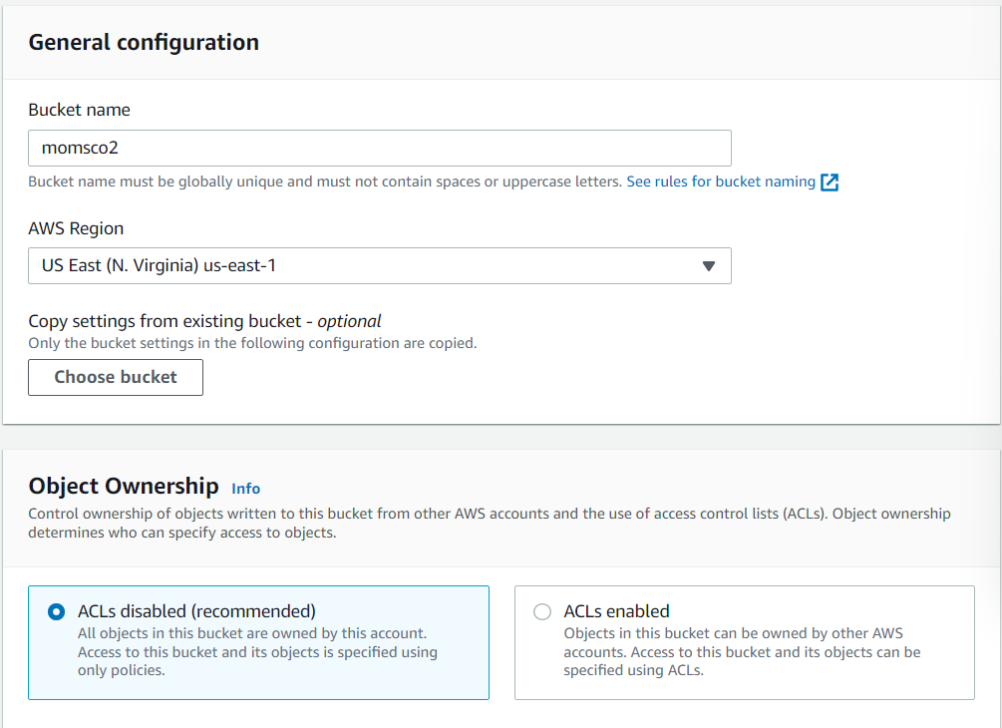

1. Check **Block all public access.**
2. 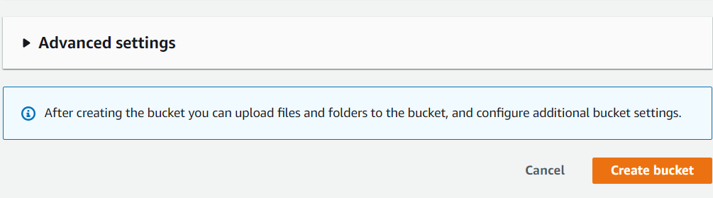Click **Create Bucket.**
3. Click on Bucket name to enter into our bucket.



1. Choose **upload** and **‘add files’** or **‘add folders’** upload the required files or folders.

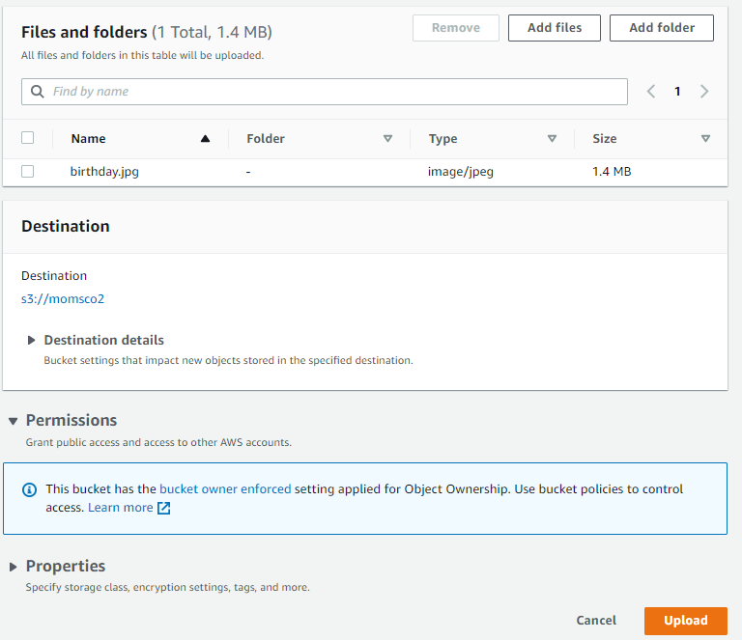

1. Click **Upload**, after upload completion click **Close**.

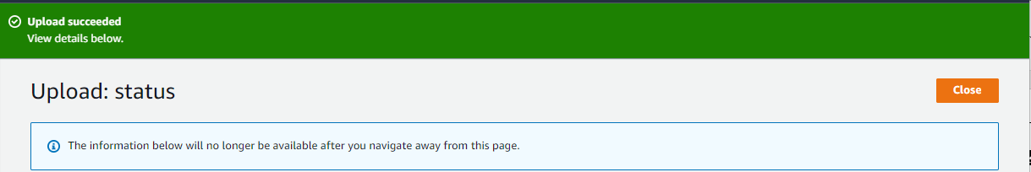

1. Click on the file, copy object url and open it to see if access is denied or not.

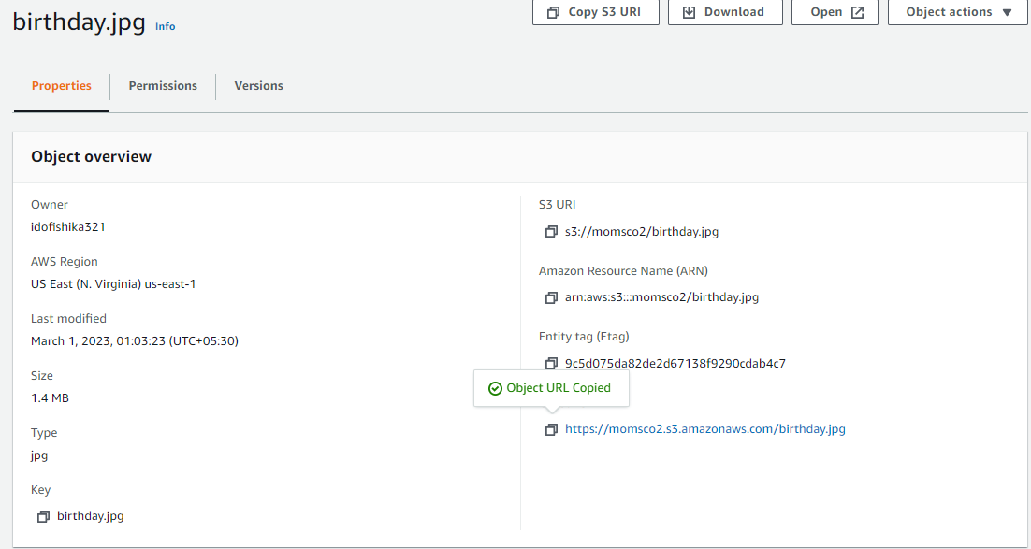

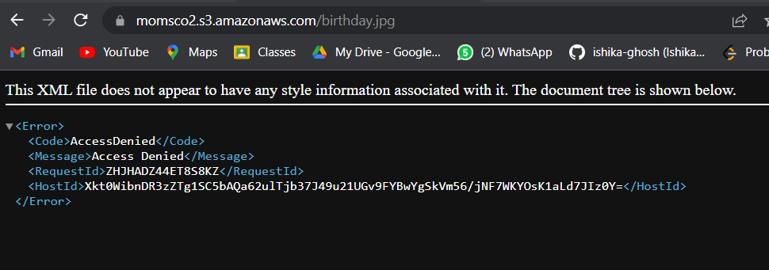

1. Go back and select the document, click actions and select share with a presigned url.

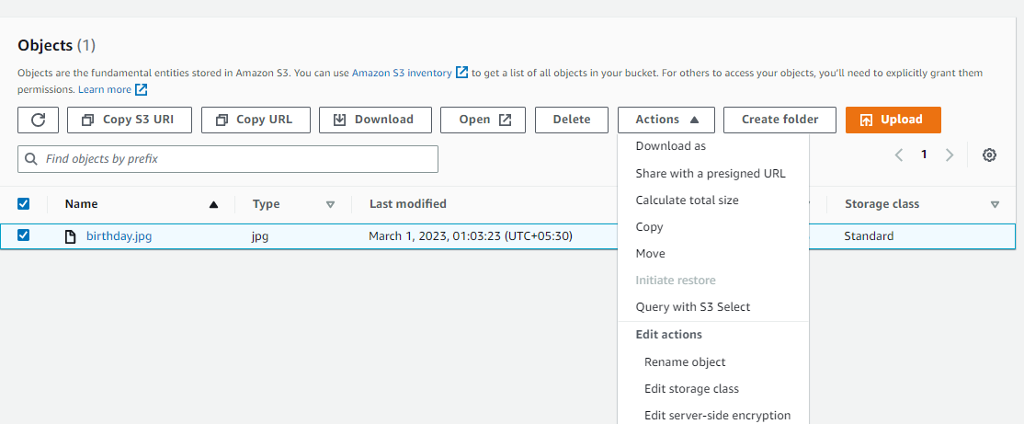

1. Set the time limit and click create presigned url. Now copy the presigned url and paste on another browser.

